Lab Assignment part 1

In this part, I just modified the code which is downloaded from the box app. I have used the sensor on the Android device named pedometer and I wrote the code for the to-do tasks.

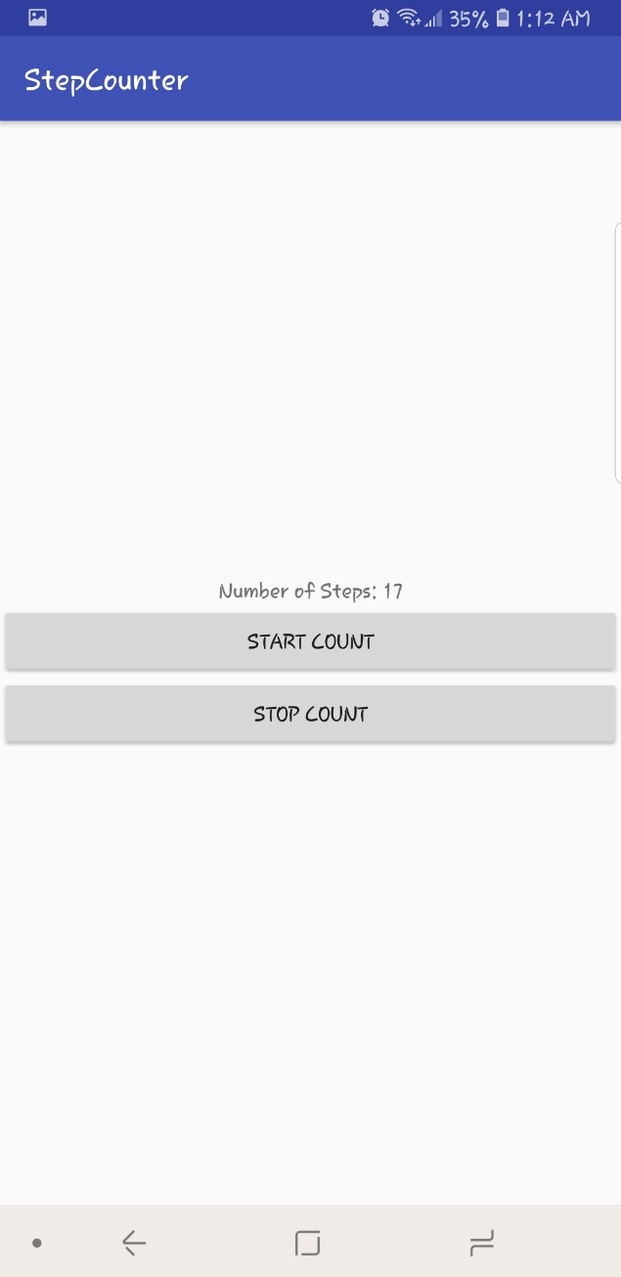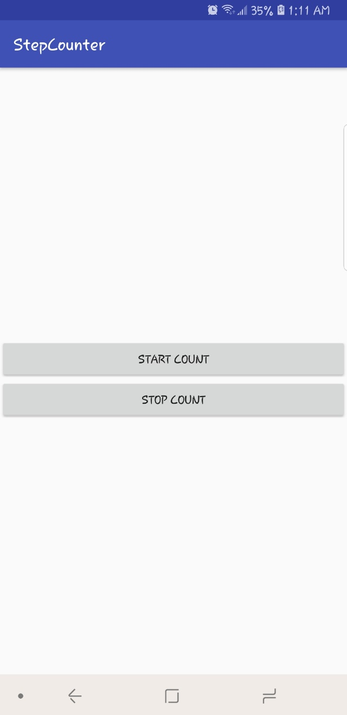

Lab Assignment part 2

In this part, I created an app that detects the face and face attributes like a smile from the image.

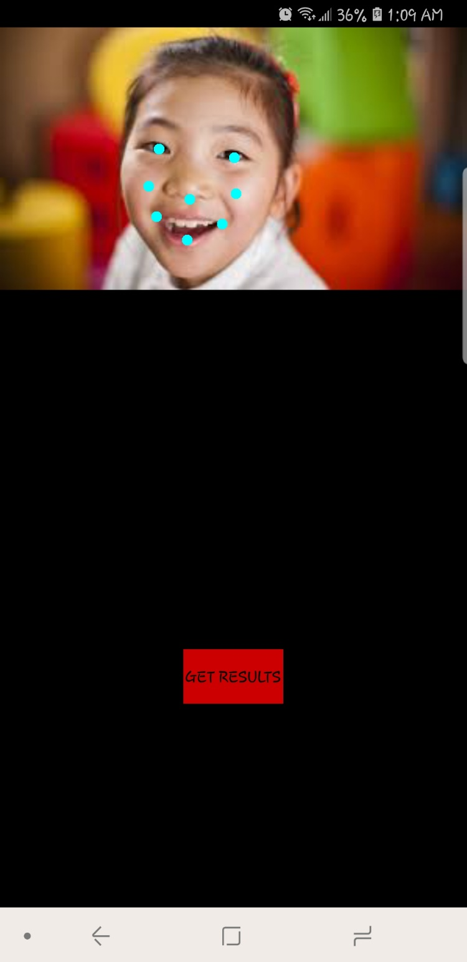

The output for the first image as follows

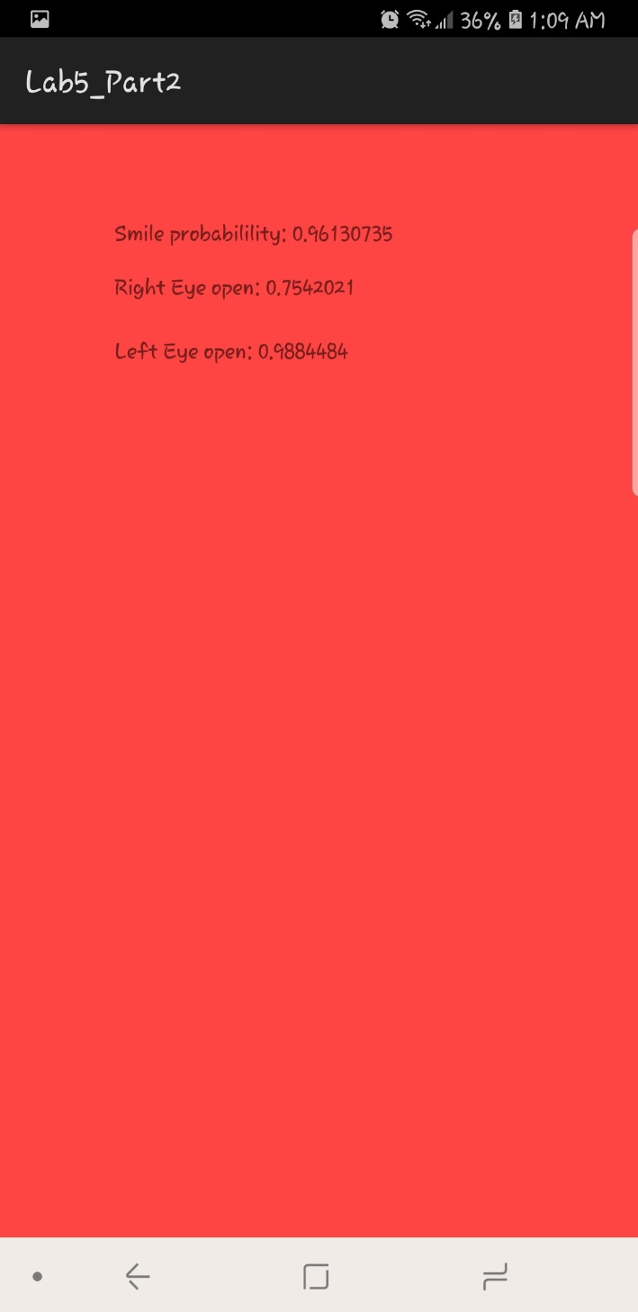

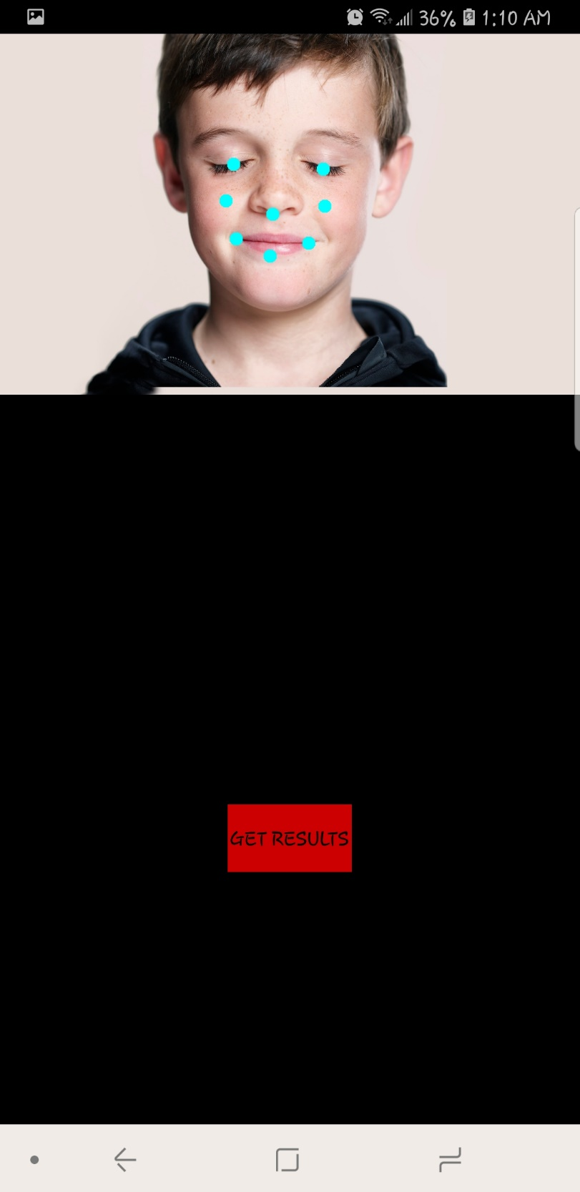

The output for the second image as follows

